Code Q1

;21L-7512 Abdullah Dar BSCS 3G MID Q1

[org 0x0100]

jmp start

arr: db 7,4,8,2,7,7,9,5,6,1 ; array

min: db 0 ; storing min

max: db 0 ; storing max

updatemin:

mov [min],al ; update min

jmp return1

updatemax:

mov [max],al ;update the max

jmp return2

start:

mov cx,10 ; size of array

mov si,0 ; si used for indexing

mov al,[arr+si] ; placing first ele in al

mov [min],al ; placing first index at min and max

mov [max],al

loop1:

mov al,[arr+si] ; checking witj al register

cmp al,[min] ; comparing

jl updatemin ; if al has smaller value than min then jump for updation

return1:

cmp al,[max] ; cmp al with max

jg updatemax ; if al has greater value than max than jmp for updation

return2:

inc si ; inc si for next index

cmp si,cx ; cmp si with size of array

jne loop1 ; loop till si eqaul size

mov ax,0x4c00 ;termination here

int 0x21

Before run

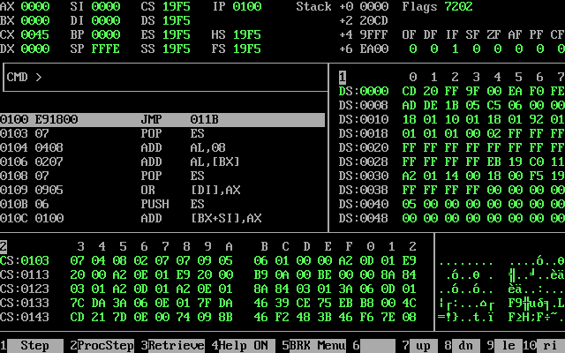

After run

Code Q2

;abdullah dar 7512

[org 0x0100]

jmp start

top: dw 330 ;starting coordinate

left: dw 470;

bottom: dw 1910 ; left coordinate

right: dw 1770

clrscr:

push es

push ax

push cx

push di

mov ax,0xb800

mov es,ax

xor di,di

mov ax,0x0720

mov cx,2000

cld

rep stosw

pop di

pop cx

pop ax

pop es

ret

drawrect:

push bp

mov bp,sp

push ax

push bx

push cx

push dx

push es

push di

mov ax,0xb800

mov es,ax

mov di,[bp+10]

mov bx,[bp+8]

loop1:

mov word[es:di],0x072B

add di,2

cmp di,bx

jne loop1

mov bx,[bp+6]

loop2:

mov word[es:di],0x077c

add di,160

cmp di,bx

jne loop2

mov bx,[bp+4]

loop3:

mov word[es:di],0x077e

sub di,2

cmp di,bx

jne loop3

mov bx,[bp+10]

loop4:

mov word[es:di],0x077c

sub di,160

cmp di,bx

jne loop4

pop di

pop es

pop dx

pop cx

pop bx

pop ax

pop bp

ret 8

start:

call clrscr

mov ax,[top]

push ax

mov ax,[left]

push ax

mov ax,[bottom]

push ax

mov ax,[right]

push ax

call drawrect

mov ax,0x4c00

int 0x21



